**DAILY ONLINE ACTIVITIES SUMMARY**

|  |  |  |  |  |  |  |  |  |
| --- | --- | --- | --- | --- | --- | --- | --- | --- |
| **Date:** | **22/05/2020** | | | | | **Name:** | **Soundarya R** | |
| **Sem & Sec** | **6th & B** | | | | | **USN:** | **4al17cs096** | |
| **Online Test Summary** | | | | | | | | |
| **Subject** | | **Operating Research** | | | | | | |
| **Max. Marks** | | **30** | | **Score** | | | **5** | |
| **Certification Course Summary** | | | | | | | | |
| **Course** | **Python for Machine Learning** | | | | | | | |
| **Certificate Provider** | | | **Great Learning Academy** | | **Duration** | | | **5hours** |
| **Coding Challenges** | | | | | | | | |
| **Problem Statement:** 3 Programs | | | | | | | | |
| **Status: Solved** | | | | | | | | |
| **Uploaded the report in Github** | | | | | **yes** | | | |
| **If yes Repository name** | | | | | <https://github.com/ashu102/Daily-Activities> | | | |
| **Uploaded the report in slack** | | | | | **yes** | | | |

IA TEST

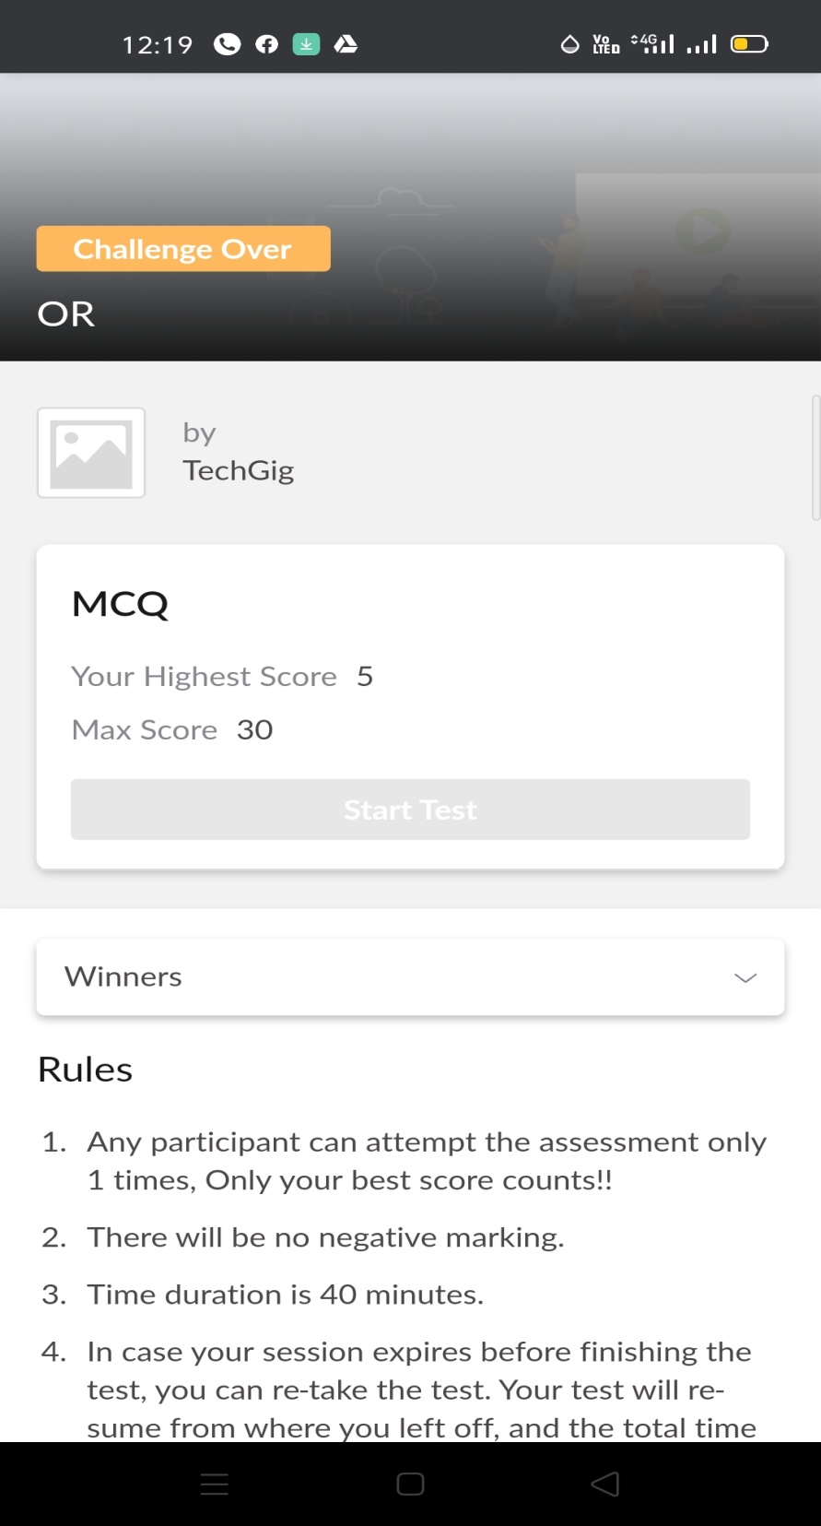

CERTIFICATION COURSE

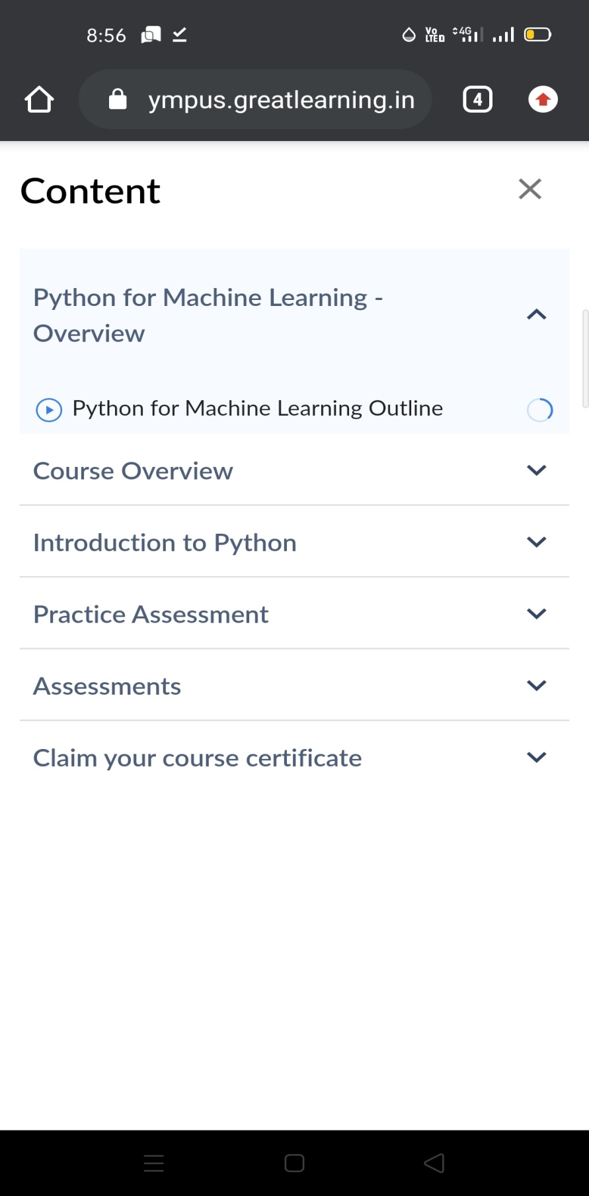

ONLINE CODING

Program1 :

